



**Understanding and using Skin Cancer Profiles**

**Tools available**

The Skin cancer profiles are interactive web-based tools which show both numerical data and maps. Profiles are presented at two different geographical levels:

* Clinical Commissioning Groups
* Local/Unitary Authorities

Data is shown in thematic maps, as a bar chart or in the spine chart section. In the majority of cases, indicator data will include a rate, confidence intervals, numerator data, regional averages and the England average.

**The spine chart**

When an area is selected the spine chart is populated for all indicators. Columns will be filled with (from left to right): the area name, rate for that area, numerator, rate for England and significance compared to England. A graphic is displayed which indicates a number of properties:

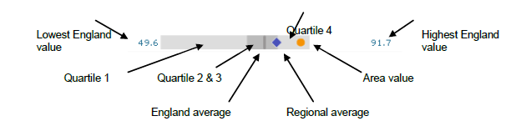

The England, regional and area values are denoted on a background which indicates the range and distribution of values nationwide. Quartiles are the range of values which contain one-quarter of the areas displayed, hence quartiles 2 and 3 contain half the areas of interest.

**Indicators**

The skin cancers are based on ICD-code C43 for Malignant Melanoma.

The main summary statistics have been extracted from the National Cancer Registration Service (NCRS) namely: incidence, mortality. These are separated by sex where appropriate.

In line with United Kingdom Association of Cancer Registries (UKACR) guidance, numerators of less than five have been suppressed, along with rates and other data based on those numerators. These are labelled in the charts.

At smaller geographies there may be many areas which are suppressed. If too many areas are suppressed the indicator is less meaningful and is not displayed in the tool, this is generally done when over half the areas have suppressed data.

In addition to specific cancer data there are certain associated indicators listed, where available. These are intended to give context to the cancer-related indicators by summarising the general health of an area, or highlighting risk factors.

**Confidence intervals and significance**

Indicator data is presented with 95% confidence intervals, which are displayed on the bar chart. A confidence interval is a statistical expression of uncertainty of a number, which can be interpreted in two ways:

If taking a sample of measurements from a group, the 95% confidence intervals denote a range of values in which, 19 times out of 20, the true value would fall if we repeated the sample many times.

When looking at a value in a population at a given time, the 95% confidence intervals denote a range of values in which, 19 times out of 20, the true value would fall if the same population were followed over the same time. This is due to natural fluctuations in rates of disease which always occur.

The second interpretation is most appropriate in this instance. The width of the confidence intervals depends on the number of people or cases taken into account, and become larger for smaller numbers. This is why it is difficult to assess whether there is any true change in a rate of rare diseases, or in small areas, beyond natural fluctuation.

Statistical significance is an expression of whether we can understand two numbers to be truly different or not. It can be crudely derived by assessing whether the confidence intervals on a number overlap. More correctly it can be assessed by tests which take into account the numerators involved and the standard errors. For the rates displayed in the skin cancer profiles a *z*-test of the rate ratios is used to determine statistical significance compared to the England average (Kirkwood & Sterne, 2003).

The calculated statistical significance is denoted by a red circle if worse than the England average, a green diamond if better, and a grey line if there is no significant difference. If the significance column is blank then no statistical significance could be calculated or it was suppressed because of small numbers.

**References**

Kirkwood, B., & Sterne, J. (2003). *Medical Statistics.* Oxford: Blackwell Science.